Sentiment Analysis – A Comparative Study

Class: Artificial Intelligence (CSC-447-UT1, CSC-547-UT1)

Department of Computer Science
University of South Dakota

Group members
Neerajdattu Dudam (Grad)
Teja Mallireddy (Grad)

Supervisor: Dr. Lina Chato

Spring 2025

Objective
This project aims to perform sentiment analysis of text, categorizing it into positive, negative, and neutral sentiments using a variety of machine learning and deep learning techniques. We will provide a comprehensive and comparative study of these techniques. Our objectives include:
- Lexicon-Based Approach:
  - Implementing different analyzers such as VADER, AFINN, and SentiWordNet.
  - Utilizing other lexicon-based techniques like the TextBlob sentiment analyzer and WordStat.
- Traditional Machine Learning Techniques:
  - Employing classical algorithms such as Naive Bayes, Logistic Regression, Support Vector Machines (SVM), Decision Trees, and Random Forests.
  - Exploring additional methods like k-Nearest Neighbors (k-NN) and Gradient Boosting Machines (GBM).
- Deep Learning Techniques:
  - Implementing advanced models such as Recurrent Neural Networks (RNN) with LSTM and GRU, and Convolutional Neural Networks (CNN) with n-grams.
  - Exploring complex transformer-based models like BERT, its derivatives, and GPT models.
  - Investigating other neural network architectures like Bidirectional LSTMs (BiLSTM) and Attention Mechanisms.
  - Applying hybrid models that combine CNNs and RNNs for improved sentiment classification.
- Other Techniques:
  - Utilizing ensemble methods to combine multiple models and improve performance.
  - Applying feature engineering techniques like TF-IDF, word embeddings (e.g., Word2Vec, GloVe), and sentence embeddings (e.g., Universal Sentence Encoder).
  - Experimenting with unsupervised and semi-supervised learning methods for sentiment analysis.
The goals of the project are:
- To gain a comprehensive understanding of Natural Language Processing (NLP) and the various techniques used for sentiment analysis.
- To appreciate the significance of sentiment analysis in real-world applications and daily tasks.
- To develop practical skills in implementing and evaluating different sentiment analysis models.
By the end of the project, we aim to have a well-rounded knowledge of sentiment analysis techniques and their applications, as well as hands-on experience with various NLP tools and models.

Data
For this project, we will use the Dynasent dataset (v1.1), which provides a rich and diverse text corpus suitable for sentiment analysis tasks. This dataset includes labeled text samples, making it ideal for training and evaluating our models. The dataset contains the following files:
- Training Set:
  - Yelp data
  - Dynabench data
- Testing Set:
  - Yelp data
  - Dynabench data
- Validation Set:
  - Yelp data
  - Dynabench data
- The link to download the data - dynasent/dynasent-v1.1.zip at main · cgpotts/dynasent
These files will provide comprehensive coverage for our sentiment analysis techniques, allowing us to compare and contrast different approaches effectively.
Here is the summary of the data:
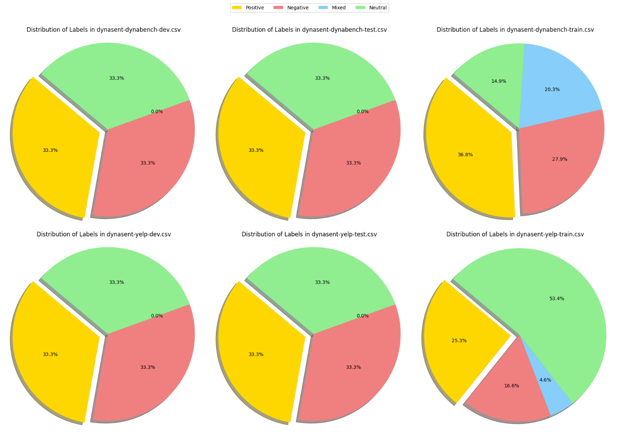

Hypothesis
The hypothesis for this project is that different sentiment analysis techniques will yield varying levels of accuracy and effectiveness in classifying text into positive, negative, neutral, and mixed sentiments. We anticipate that:
- Lexicon-based approaches, while straightforward and easy to implement, may have limitations in handling context and nuanced expressions.
- Traditional machine learning methods will provide a good balance between simplicity and performance but may require extensive feature engineering.
- Deep learning techniques, especially transformer-based models, will achieve the highest accuracy due to their ability to capture complex patterns and contextual information in the text.
We aim to test this hypothesis by systematically evaluating each technique's performance on the Dynasent dataset and comparing their strengths and weaknesses.

Expectations
Through this project, we expect to achieve several key outcomes:
- A comprehensive understanding of various sentiment analysis techniques, including their theoretical foundations and practical implementations.
- Detailed insights into the performance of lexicon-based, traditional machine learning, and deep learning approaches.
- Identification of the most effective techniques for sentiment analysis based on our comparative study.
- Enhanced knowledge of natural language processing (NLP) and its applications in real-world scenarios.
By the end of this project, we hope to have a clear understanding of the advantages and limitations of each technique and be well-prepared to apply sentiment analysis in various contexts.

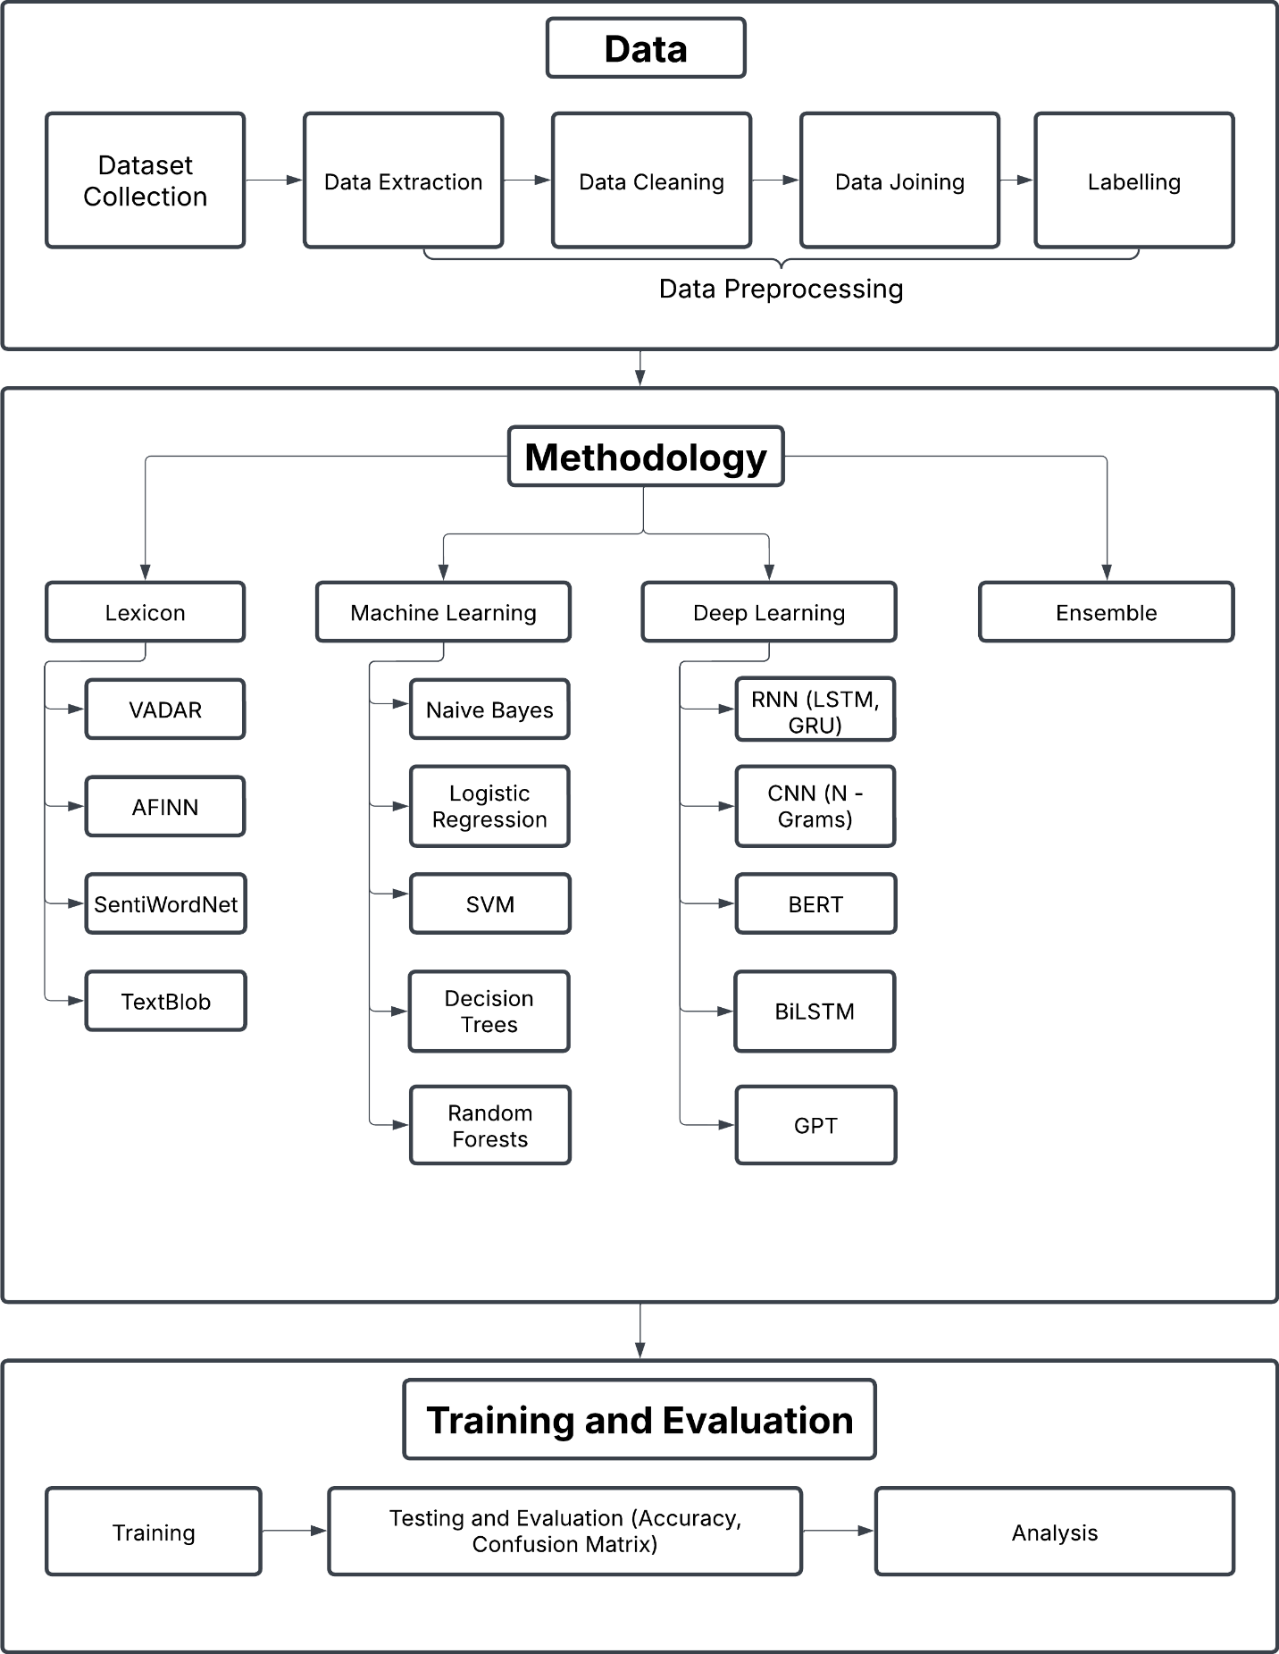
Project Process and Design

6. References
- C. Hutto and E. Gilbert, "VADER: A parsimonious rule-based model for sentiment analysis of social media text," Proc. Int. AAAI Conf. Web Soc. Media, vol. 8, no. 1, 2014.
- B. Liu, "Sentiment analysis," UIC, [Online]. Available: https://www.cs.uic.edu/~liub/FBS/sentiment-analysis.html. [Accessed: Feb. 6, 2025].
- B. Pang, L. Lee, and S. Vaithyanathan, "Thumbs up? Sentiment classification using machine learning techniques," arXiv preprint cs/0205070, 2002.
- T. Joachims, "Text categorization with support vector machines: Learning with many relevant features," in Proc. Eur. Conf. Mach. Learn., Berlin, Heidelberg: Springer, 1998, pp. 137–142.
- J. P. Vink and G. de Haan, "Comparison of machine learning techniques for target detection," Artif. Intell. Rev., vol. 43, pp. 125–139, 2015.
- T. Mikolov et al., "Distributed representations of words and phrases and their compositionality," in Adv. Neural Inf. Process. Syst., vol. 26, 2013.
- P. Liu, X. Qiu, and X. Huang, "Recurrent neural network for text classification with multi-task learning," arXiv preprint arXiv:1605.05101, 2016.
- A. Rakhlin, "Convolutional neural networks for sentence classification," GitHub, vol. 6, p. 25, 2016.
- J. Devlin, M.-W. Chang, K. Lee, and K. Toutanova, "BERT: Pre-training of deep bidirectional transformers for language understanding," in Proc. NAACL-HLT, vol. 1, no. 2, 2019, pp. 4171–4186.
- T. Brown et al., "Language models are few-shot learners," in Adv. Neural Inf. Process. Syst., vol. 33, 2020, pp. 1877–1901.
- C.-L. Chou, C.-H. Chang, and S.-Y. Wu, "Semi-supervised sequence labeling for named entity extraction based on tri-training: case study on Chinese person name extraction," in Proc. Third Workshop Semantic Web Inf. Extraction, 2014.

